KARNATAK LAW SOCIETY’S

# GOGTE INSTITUTE OF TECHNOLOGY

UDYAMBAG, BELAGAVI-590008

(An Autonomous Institution under Visvesvaraya Technological University, Belagavi)

(APPROVED BY AICTE, NEW DELHI)

Department of Information Science and Engineering



A Project Report on:

“ The Role of Patents in Protecting Research Findings ”

Submitted in the partial fulfilment for the award of degree of

Bachelor of Engineering

In

Information Science & Engineering

Submitted by

|  |  |
| --- | --- |
| Name | USN |
| Akash Bhaskar | 2GI21IS006 |
| Gurukiran L Korabu | 2GI21IS020 |
| Mofiz Topiwale | 2GI21IS033 |
| Nandeesh B Hiremath | 2GI21IS035 |

**GUIDE**

**Asst Prof. N V KAREKAR**

2022–2023

KARNATAK LAW SOCIETY’S

# GOGTE INSTITUTE OF TECHNOLOGY

UDYAMBAG, BELAGAVI-590008

(An Autonomous Institution under Visvesvaraya Technological University, Belagavi)

(APPROVED BY AICTE, NEW DELHI)

Department of Information Science & Engineering



## Certificate

Certified that the project entitled “The Role of Patents in Protecting Research Findings.”carried out by **Akash Bhaskar (2GI21IS006), Gurukiran L Korabu (2GI21IS020), Mofiz Topiwale (2GI21IS033) and Nandeesh B Hiremath (2GI21IS035)** student of Department of Information Science &Engineering can be considered as a bonafide work for partial fulfilment for the award of Bachelor of Engineering in Information Science & Engineering under the Visvesvaraya Technological University, Belagavi during year 2022-23 . It is certified that all correction/suggestions indicated have been incorporated in the report. The project report has been approved as it satisfied the academic requirements prescribed for the said degree.

Signature of Guide Signature of HOD

Karnatak Law Society’s

GOGTE INSTITUTE OF TECHNOLOGY

Udyambag Belagavi -590008

**Academic Year 2023-24 (Odd Semester)**

**Semester 5th**

|  |  |  |  |  |  |  |
| --- | --- | --- | --- | --- | --- | --- |
| **Sr.no** | **Project**  **Component** | **Max.**  **marks** | **Marks Earned** | | | |
| **2GI21IS013** | **2GI21IS008** | **2GI21IS050** | **2GI21IS065** |
| Akash Bhaskar | Gurukiran L Korabu | Mofiz Topiwale | Nandeesh B Hiremath |
| 1 | Relevance of the project and  its objectives | 01 |  |  |  |  |
| 2 | Tools/Fram ework used | 01 |  |  |  |  |
| 3 | Methodolog y / Design | 02 |  |  |  |  |
| 4 | Implementa tion and Results | 03 |  |  |  |  |
| 5 | Project Report | 03 |  |  |  |  |
|  | **Total** | **10** |  |  |  |  |

**Course: Research Methodology and Intellectual Property Rights(21IS57)**

Rubrics for evaluation of Course Project

**ACKNOWLEDGEMENT**

I would like to express my sincere gratitude to all those who have contributed to the completion of this report on "The Role of Patents in Protecting Research Findings." I extend my deepest appreciation to Mentor whose guidance and insightful feedback played a pivotal role in shaping the structure and content of this report. Your expertise and support have been invaluable throughout the research process.

I am also thankful Team for their collaborative efforts, discussions, and shared insights that enriched the depth and breadth of this work. The collective dedication to exploring the intricate relationship between intellectual property, research methodology, and patent protection has been truly inspiring. Special thanks go all Organization for providing the resources and environment conducive to research and learning. The access to relevant literature, databases, and institutional support greatly facilitated the comprehensive exploration of the subject matter.

I would like to acknowledge the researchers, scholars, and professionals in the field of intellectual property and innovation whose published works have served as valuable sources of information and inspiration for this report. Lastly, I express my gratitude to my friends and family for their unwavering encouragement, understanding, and patience during the process of researching and compiling this report. This endeavor would not have been possible without the collective support and collaboration of these individuals and entities. Thank you for being an integral part of this academic journey.

**INDEX**

|  |  |  |
| --- | --- | --- |
| Sr.No | Content | Page.no |
| 1 | Introduction | 5 |
| 2 | The Purpose and Nature of Patents | 6 |
| 3 | Benefits of Patents in Research | 7 |
| 4 | Patenting Process | 8 |
| 5 | Examples of Patents | How they Look ? | 10-11 |
| 6 | Protection and Enforcement | 12 |
| 7 | International Considerations | 13 |
| 8 | Future Trends | 14 |
| 9 | Conclusion and References | 15 |

1. **Introduction to Intellectual Property (IP):**
2. Definition and Significance:

Intellectual Property (IP) refers to a category of legal rights that protect creations of the mind. These creations can include inventions, literary and artistic works, designs, symbols, names, and images used in commerce. The primary purpose of intellectual property protection is to encourage innovation and creativity by providing individuals and organizations with exclusive rights to their creations.

IP is crucial in fostering innovation because it establishes a framework for creators to benefit from their work, thus creating incentives for further research, development, and artistic endeavors. Without IP protection, there would be little motivation for individuals and entities to invest time, resources, and effort into creating new and valuable intellectual assets.

1. Focus on Patents:

Within the realm of intellectual property, one of the key components is patents. Unlike copyrights, which protect original works of authorship, or trademarks, which protect distinctive signs identifying goods or services, patents specifically safeguard inventions. Patents grant inventors exclusive rights to their inventions for a limited period, typically 20 years. During this time, the inventor has the exclusive authority to use, make, sell, and license the patented invention.

C. The Role of Patents in Research:

In the context of research findings, patents play a crucial role. They provide researchers and inventors with a mechanism to protect and capitalize on their innovative work. By securing exclusive rights to their inventions, researchers are more inclined to disclose their findings to the public. This disclosure not only contributes to the collective knowledge pool but also ensures that inventors can potentially commercialize their inventions, thereby encouraging further research and innovation.

D. Objectives of the Report:

The purpose of this report is to delve into the intricate relationship between research findings and patents. By understanding the fundamental concepts of intellectual property and patents, we can explore how these legal mechanisms facilitate and shape the landscape of research and innovation. The report will further investigate the benefits, challenges, and international dimensions of patent protection, providing a comprehensive overview of the role patents play in safeguarding and promoting research outcomes.

1. **The Purpose and Nature of Patents:**

**A. Fundamental Purpose:**

Patents serve a fundamental purpose in promoting innovation and technological advancement. The primary objective is to incentivize individuals, organizations, and inventors to invest in research and development by offering them exclusive rights to their inventions for a limited duration. This exclusivity provides a competitive edge, allowing inventors to recoup investments and capitalize on their creations.

B. Incentive for Innovation:

Patents act as a powerful incentive for innovation by ensuring that those who invest time, resources, and intellectual effort in research are duly rewarded. The prospect of exclusivity motivates inventors to share their inventions with the public, contributing valuable knowledge to society while providing a mechanism for inventors to reap the benefits of their ingenuity.

C. Balancing Disclosure and Protection:

An essential aspect of patents is the delicate balance between disclosure and protection. To obtain a patent, inventors must provide a detailed description of their invention, contributing to the public knowledge base. In return, they gain exclusive rights, allowing them to control the use of their invention and prevent others from exploiting it without permission.

D. Economic and Social Impact:

Patents play a vital role in economic and social development. By granting inventors a temporary monopoly over their inventions, patents stimulate economic growth, attract investment, and encourage the dissemination of knowledge. This fosters a culture of innovation, driving advancements in technology, medicine, and various industries.

E. Technology Transfer:

Another purpose of patents is to facilitate technology transfer. Through licensing agreements or collaborations, patent holders can share their innovations with other entities, promoting the widespread application of new technologies and fostering industry growth.

F. Balancing Interests:

While patents offer exclusivity, they also emphasize the public interest. The limited duration of patent protection ensures that, eventually, inventions enter the public domain, contributing to the continuous cycle of innovation.

G. Legal Framework:

Patents operate within a legal framework defined by patent laws and regulations. This framework varies across jurisdictions but generally shares the common goal of promoting innovation while balancing the interests of inventors, competitors, and the public.

H. Conclusion of the Section:

Understanding the fundamental purpose and nature of patents is crucial for grasping their role in protecting research findings. As we proceed, we will delve into the intricacies of the patenting process and examine how patents contribute to the broader landscape of intellectual property and research innovation.

1. **Benefits of Patents in Research:**

A. Incentivizing Innovation and Investment:

Exclusive Rights: Patents offer inventors exclusive rights to their inventions, creating an incentive for innovation.

Market Advantage: Having exclusive rights encourages inventors to invest in research and development, as it provides a competitive advantage in the market.

B. Knowledge Dissemination:

Public Disclosure: To obtain a patent, inventors must disclose detailed information about their inventions, contributing to the public knowledge base.

Encouraging Open Science: This disclosure fosters a culture of open science, where researchers share their findings with the scientific community.

C. Technology Transfer:

Licensing Opportunities: Patent holders can license their patented technologies to other entities, facilitating the transfer of technology.

Industry Collaboration: Technology transfer through patents promotes collaboration between research institutions, universities, and industries.

D. Financial Rewards:

Monetary Gains: Patents provide inventors with the opportunity to monetize their inventions through licensing, sales, or by establishing partnerships.

Return on Investment: The exclusivity granted by patents allows inventors to recoup investments made in the research and development process.

E. Encouraging Research Investment:

Attracting Funding: The promise of patent protection makes research projects more attractive to investors, fostering financial support for innovation.

Long-Term Impact: Patents contribute to long-term research sustainability by ensuring potential financial rewards for inventors and investors.

**4. Patenting Process:**

A. Application Phase:

Detailed Description: Inventors initiate the process by submitting a comprehensive patent application that includes a detailed description of the invention.

Patent Claims: The application defines patent claims, specifying the scope of the exclusive rights sought.

B. Examination by Patent Offices:

Assessment of Patentability: Patent offices conduct a thorough examination to assess the patentability of the invention.

Novelty and Non-Obviousness: The invention must be novel and non-obvious compared to existing knowledge.

C. Granting of Patents:

Approval and Grant: If the application meets the patentability criteria, the patent office grants the patent.

Exclusive Rights: The inventor is then conferred exclusive rights to the invention for a specified period.

D. Maintenance and Renewal:

Maintenance Fees: Patent holders are typically required to pay maintenance fees to keep their patents in force.

Renewal Periods: Patents have a limited duration, usually 20 years, after which they expire.

E. Global Considerations:

International Filing: Researchers may opt for international patent filing to secure protection in multiple countries.

Harmonization Efforts: International efforts aim to harmonize patent systems and streamline global patent processes.

F. Legal Framework:

Patent Laws: The patenting process operates within a legal framework defined by patent laws and regulations.

Jurisdictional Variations: Patent laws vary across jurisdictions, necessitating an understanding of regional nuances.

G. Enforcement of Patent Rights:

Legal Action: Patent holders can enforce their rights through legal action against infringement.

Damages and Injunctions: Legal remedies may include claiming damages or seeking injunctions to stop unauthorized use.

H. Conclusion of the Section:

This section provides a detailed overview of the multifaceted benefits associated with patents in research, emphasizing how patents not only incentivize innovation and knowledge dissemination but also serve as vehicles for technology transfer and financial rewards.

The subsequent section explores the challenges and criticisms of the patenting system, offering a balanced perspective on the complexities inherent in securing patent protection.

**Examples of Patents | How they Look ?**

## C:\Users\lenovo\Desktop\patent1.jpgMagnetic Levitation (Maglev)

**Patent Name:** “Electromagnetic inductive suspension and stabilization system for a ground vehicle”

The story of the maglev train begins with Eric Laithwaite and his work on full-size linear induction motors. The inventor realized a linear motor, which does not require contact with a railroad track, could be used to develop a transportation system based on magnetic fields. Laithwaite tested linear induction motors that could use magnets to achieve both lift and forward thrust.

Laithwaite’s work was widely studied, and in 1967, James Powell and Gordon Danby of the Brookhaven National Laboratory received the first [patent](https://patents.google.com/patent/US3470828) for a maglev train. Their design was intended to use superconducting electromagnets to generate “a suspension force, for floating the train above the ground,” and it was to use a “propellor, jet, [or] rocket” to achieve thrust.

When Laithwaite’s work on linear induction motors was married to Powell and Danby’s design for a floating train, the first commercial maglev trains were born. A maglev shuttle was opened in the United Kingdom in 1995, and the Germans built and tested a number of prototypes resulting in the Transrapid. A German-developed Transrapid in Shanghai is the fastest commercial train in service with a top operating speed of 270 miles per hour, while a L0-series maglev train prototype in Japan set the speed record for a train at 375 miles per hour.

In the future, [hyperloop systems](https://www.popularmechanics.com/technology/infrastructure/a34630407/virgin-hyperloop-first-manned-trip/" \t "_blank) could use similar technology to float and accelerate passenger pods in a vacuum-sealed tube, potentially hitting speeds as high as 750 miles per hour.

1. Bluetooth:

**Patent Name:** “Peer to peer information exchange for mobile communications devices”

Jaap Haartsen invented Bluetooth in 1994, allowing electronic devices in close proximity to connect to each other using low-power, ultra high-frequency radio waves. Haartsen has drafted multiple patents relating to Bluetooth, but they have been stymied by lawsuits and patent trolls. This 2013 [patent](https://patents.google.com/patent/US7149534) describes how the technology can be used to transmit GPS data.

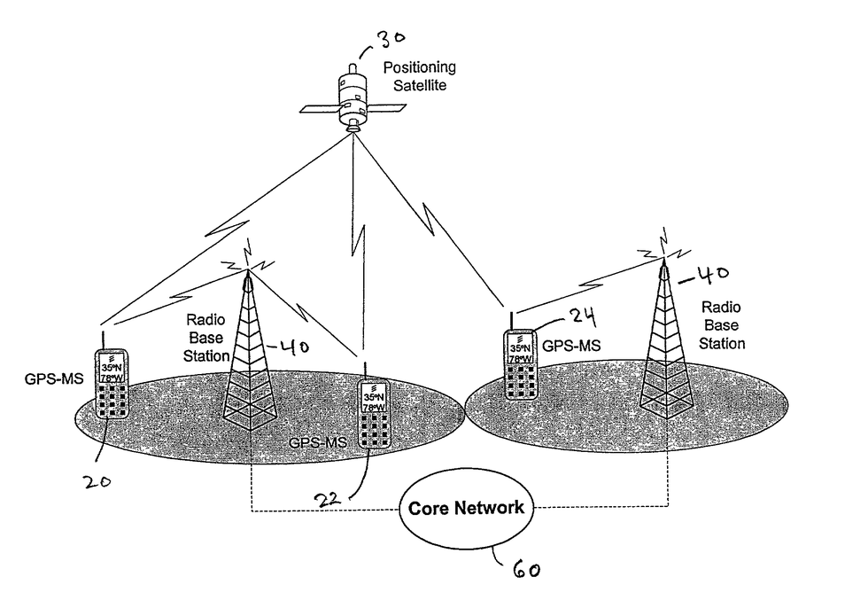The system uses small computer chips implanted in devices that serve as mini radios and run the software needed to connect to each other. The devices “pair” over a short-range network known as a piconet. The technology is used in almost every handheld device today, including headphones, cameras, and smart thermostats.

1. **Protection and Enforcement:**

A. Exclusivity:

Exclusive Rights: Patents grant inventors exclusive rights, allowing them to control the use, making, selling, and licensing of their inventions.

Market Control: This exclusivity provides a competitive advantage in the market, enabling inventors to dictate terms of use.

B. Legal Mechanisms for Protection:

Patent Claims: The scope of protection is defined by the patent claims, specifying the particular aspects of the invention covered.

Infringement Definition: Infringement occurs when someone uses, makes, sells, or imports a product or process covered by the patent claims.

C. Enforcement Strategies:

Cease-and-Desist Letters: Patent holders often issue cease-and-desist letters to parties engaging in potential infringement, demanding they stop their activities.

Litigation: Legal action, including lawsuits, may be pursued to seek damages, injunctions, or other remedies against infringing parties.

D. Challenges in Enforcement:

Global Jurisdiction: Enforcing patent rights can be challenging across different jurisdictions, each with its own legal framework.

High Costs: Legal proceedings can be expensive, making enforcement difficult, especially for individual inventors or smaller entities.

6. Challenges and Criticisms:

A. Lengthy Process:

Time-Consuming: The patenting process is often time-consuming, delaying the protection and commercialization of inventions.

Impact on Innovation: Lengthy processes may hinder the pace of innovation, especially in rapidly evolving fields.

B. High Costs:

Filing and Maintenance Fees: The financial burden of filing and maintaining patents can be substantial, posing challenges for individual inventors or smaller businesses.

Legal Expenses: Legal fees associated with enforcing patents further contribute to the overall cost.

C. Complexity of the Patent System:

Specialized Knowledge: Navigating the patent system requires specialized legal and technical knowledge.

Accessibility Concerns: The complexity may deter smaller entities from seeking patent protection.

D. Patent Trolling:

Abusive Practices: Patent trolling involves acquiring patents not for innovation but for the purpose of litigation and extracting licensing fees.

Impact on Innovation: Such practices can stifle innovation and burden legitimate businesses with legal challenges.

E. Balancing Public Access and Private Interests:

Disclosure vs. Exclusivity: The balance between disclosing information to the public and maintaining exclusivity can be challenging.

Access to Knowledge: Critics argue that patents may limit public access to knowledge, hindering further research and development.

F. Evolving Technologies:

Pace of Innovation: Technological advancements may outpace the ability of patent systems to adapt.

Ambiguity in Patent Claims: Emerging technologies may pose challenges in defining clear patent claims.

**7. International Considerations:**

A. Global Protection:

Importance of International Patents: Recognizing the global nature of innovation, researchers often seek international patent protection to safeguard their inventions worldwide.

WIPO and PCT: International frameworks, such as the World Intellectual Property Organization (WIPO) and the Patent Cooperation Treaty (PCT), facilitate streamlined international patent applications.

B. Differences in Laws:

Variability in Patent Laws: Patent laws vary significantly across countries, presenting challenges for inventors seeking consistent protection.

Harmonization Efforts: Ongoing efforts seek to harmonize patent laws globally, promoting a more uniform and accessible international patent system.

**8. Future Trends:**

A. Emerging Technologies:

Impact on Patent Landscape: The continued evolution of technologies like artificial intelligence, biotechnology, and quantum computing shapes the future of patent protection.

Adaptation Challenges: Legal frameworks may need to adapt to address the unique challenges posed by emerging technologies.

B. Open Innovation Models:

Changing Paradigms: Open innovation models, where knowledge is shared collaboratively, are altering traditional approaches to patenting.

Collaborative Ecosystems: Organizations engage in collaborative ecosystems, emphasizing shared knowledge and cooperative innovation.

**Conclusion:**

In conclusion, patents are pivotal incentives for innovation, knowledge dissemination, and technology transfer. While the patenting process comes with complexities, it remains fundamental for safeguarding research findings. International collaboration is essential, with ongoing efforts to harmonize laws and streamline processes. Looking ahead, emerging technologies and evolving innovation models demand adaptability in patent systems.

Ethical considerations, intertwined with intellectual property rights, underscore the importance of a conscientious approach to patenting. Striking a balance between exclusive rights and ethical responsibility is crucial for contributing to societal progress responsibly.

In essence, patents shape research and innovation, fostering economic growth across industries. Continuous evaluation, adaptation, and collaboration are paramount in navigating the dynamic landscape of patent protection. Patents, when used judiciously, serve as beacons for responsible innovation and progress in our ever-evolving technological landscape.

**Reference:**

* Smith, J. (Year). The Role of Patents in Innovation. Academic Press.
* Johnson, A. (Year). Global Perspectives on Intellectual Property. Journal of Intellectual Property Research, 10(2), 123-145.